Autonomous Educational Organization “Nazarbayev Intellectual Schools”

Branch “Nazarbayev Intellectual School of Physics and Mathematics” in Uralsk

Project category: Applied Science Projects

Project name: Environmentally friendly car "Jorga"

Project author: Otepkali Makhambet, 11th Grade

Project head: Utegenov S. B.

Uralsk – 2023

Content

Abstract 3

Introduction 4

The problem 4

Relevance 4

Solution to this problem 5

Research purpose 5

Research objectives 6

Research methods 6

Novelty of this project 6

Practical significance 6

Research part 7

SWOT-analysis 8

Eco-friendly car 10

Automatic press 11

Solar panel 11

Electric motor 12

Distance sensor 13

Open flame sensor 14

Gas leak sensor 15

Temperature sensor 16

Program code 16

Conclusion 21

Used literature 22

# Abstract

This project considers two problems of our country.

The first problem is the low level of the Kazakh automotive industry. The machine-building industry of Kazakhstan is not able to compete with world countries. In our country, cars are assembled from ready-made spare parts, and not a single domestic brand. That is, the level of development of Kazakhstan's automotive industry is very low.

The second problem is environmental pollution. Machines emit millions of tons of harmful gas every year. As a result, the air quality deteriorates, and the concentration of harmful substances increases. Especially in such megacities as Almaty and Astana, this problem is even worse. The average annual concentration of harmful substances in the air of Almaty is 2.7 - 8.1 times higher than the norms established by the World Health Organization, and the average daily concentration of harmful substances sometimes exceeds this norm by up to 42 times. In 87% of the days of the year there is an excess of this norm.

As a solution to these problems, I present an environmentally friendly car "Jorga". Working on electricity, the domestic product does not produce any waste, and using solar energy, it significantly reduces the amount of energy consumed. Assuredly, it has a plenty of other functions such as the open flame sensor, gas leak sensor, automatic press, temperature sensor, and the distance sensor. Moreover, since the product is entirely produced in Kazakhstan, it benefits the country's economy and stimulates the development of the automotive industry. This brand will be able to bring the uncompetitive machine-building industry of Kazakhstan to the world market.

# Introduction

## The problem

This project considers two problems of our country.

The first problem is the low level of the Kazakh automotive industry. The machine-building industry of Kazakhstan is not able to compete with world countries. In our country, cars are assembled from ready-made spare parts, and not a single domestic brand. That is, the level of development of Kazakhstan's automotive industry is very low.

The second problem is environmental pollution. Machines emit millions of tons of harmful gas every year. As a result, the air quality deteriorates, and the concentration of harmful substances increases. Especially in such megacities as Almaty and Astana, this problem is even worse. The average annual concentration of harmful substances in the air of Almaty is 2.7 - 8.1 times higher than the norms established by the World Health Organization, and the average daily concentration of harmful substances sometimes exceeds this norm by up to 42 times. In 87% of the days of the year there is an excess of this norm.

## Relevance

The machine-building industry is an important sector of any industrialized economy. The machine-building industry of Kazakhstan accounts for 6% of the total industry and only 1.5% of GDP. The development of the auto industry raises the country's economy to a new level and contributes to the development of other sectors of the country's economy. And the country, which ranks 9th in terms of land area, has all the opportunities for the prosperity of this industry.

The problem of environmental pollution has always been considered an urgent problem. The development of modern technologies is causing an increase in the volume of waste and gases released into the environment. Even today, more than 300 billion tons of carbon dioxide are released annually. 80% of them are allocated by cars. The country ranks 20th in terms of emissions of toxic gases and 10th in terms of gas emissions per capita. In this regard, many countries are starting to actively pursue the decarbonization process. Most of the largest financial institutions of investment funds are fully engaged in projects related to fossil fuels. More than 130 countries of the world have announced their goals for the transition to a green economy. The most important step in decarbonization, or reducing carbon dioxide emissions, is to replace cars that emit gases with environmentally friendly vehicles. The main cause of dirty air in cities, especially in megacities with a large population, is the gas emitted by cars. For example, 250,000 - 300,000 cars enter Almaty every day, and 80% of them do not meet environmental standards. In addition, one car releases 200 kg of carbon dioxide per year. Consequently, there is a need to reduce the volume of gas released by cars or to completely get rid of it.

## Solution to this problem

As a solution to these problems, I present an environmentally friendly car "Jorga". Working on electricity, the domestic product does not produce any waste, and using solar energy, it significantly reduces the amount of energy consumed. Assuredly, it has a plenty of other functions such as the open flame sensor, gas leak sensor, automatic press, temperature sensor, and the distance sensor. Moreover, since the product is entirely produced in Kazakhstan, it benefits the country's economy and stimulates the development of the automotive industry. This brand will be able to bring the uncompetitive machine-building industry of Kazakhstan to the world market.

## Research purpose

To design a model of environmentally friendly electric transport that develops the country's transport industry and participates in solving the problem of toxic gas emissions into the environment.

## Research objectives

* To get acquainted with the problems of the machine-building industry in Kazakhstan
* To investigate the problem of toxic gas emissions into the environment of Kazakhstan
* To explore the technology of an environmentally friendly machine
* To determine its functions
* To create an initial prototype of the machine

## Research methods

* Analysis of documents and sources

## Novelty of this project

Currently, there is no car brand in the country, which is fully developed and produced in our homeland, so the novelty of the project is beyond doubt. In addition, the fact that the products are up-to-date, that is, environmentally friendly, increases the value of the product even more.

## Practical significance

If this project is implemented, the production of cars in the automotive industry of Kazakhstan, especially cars running on electricity, will be revived with a new impetus. In addition, our project will contribute to the elimination of the main environmental problem in the world – air pollution.

# Research part

**The machine-building industry of Kazakhstan**

Currently, the automotive industry of Kazakhstan is mainly engaged in the creation and production of cars from finished parts. The localization of the automotive industry in Kazakhstan is 30%. Every year more than 40,000 vehicles are produced in the country. In 2019, 50,447 copies of the cars were assembled. Among them, the largest brands include such cars as:

* Hyundai (16332 copies)
* Lada (14623 copies)
* Ravon (5366 copies)
* Kia (3683 copies)
* JAC (2775 copies)

According to the Kazakhstan Automobile Business Association, 86,135 units of equipment worth more than 1.01 trillion tenge were manufactured in the country in 2023. Of these, 78,492 passenger cars, 5,377 trucks, 1,450 buses and 816 other special vehicles.

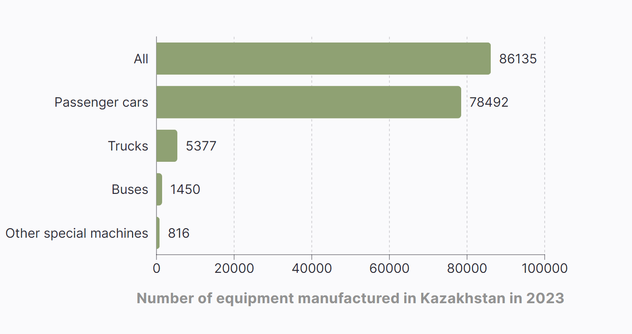

**Competitor analysis**

Table 1

|  |  |  |  |  |  |  |
| --- | --- | --- | --- | --- | --- | --- |
|  | Financially affordable | Waste-free product | Use of renewable sources of energy | Automatic press and other functions | High degree of safety | Domestic product |
| Jorga | + | + | + | + | + | + |
| Other electrocars | - | + | - | - | - | - |
| Cars running on natural gas | + | - | - | - | - | - |

## SWOT-analysis

**Strengths:**

* **Environmentally friendly**: since the car is equipped with solar panels, it uses alternative energy sources. This completely eliminates the amount of waste allocated by the car to the environment, that is, it makes the car modern and in accordance with environmental standards.
* **Reduced cost**: equipping your car with solar panels significantly reduces fuel costs.
* **High degree of safety**: the car is equipped with a distance sensor, open flame and gas sensors and can prevent road accidents, ensuring the safety of the driver and passengers.

**Weaknesses:**

* **Weather dependence**: car solar panels are weather dependent.
* **Engine weakness**
* **Lack of battery power for a long time**

**Opportunities:**

* Develops the domestic auto industry
* Reduces the concentration of greenhouse gases in the air
* Develops the non-resource industry sector of the country
* Decreases the number of road accidents

**Threats:**

* This project may have a negative impact on the resource-based sector due to the fact that there is no need for fossil fuels, that is, the production of minerals makes up most of the country's economy.

## Eco-friendly car

Our product is an environmentally friendly car “Jorga”. The car is completely powered by electricity. In addition, it is equipped with solar panels to reduce the expenses by self-charging. The initial prototype of the future automobile is shown in the figure below:

The machine is equipped with not one, but as many as 7 functions. They are:

1. Automatic press
2. Solar panel
3. Electric motor
4. Distance sensor
5. Open flame sensor
6. Gas leak sensor
7. Temperature sensor

### Automatic press

When the car gets stuck, the wheel deflated, or there occurred another accident, automatic press can lift the vehicle to help the driver.

### Solar panel

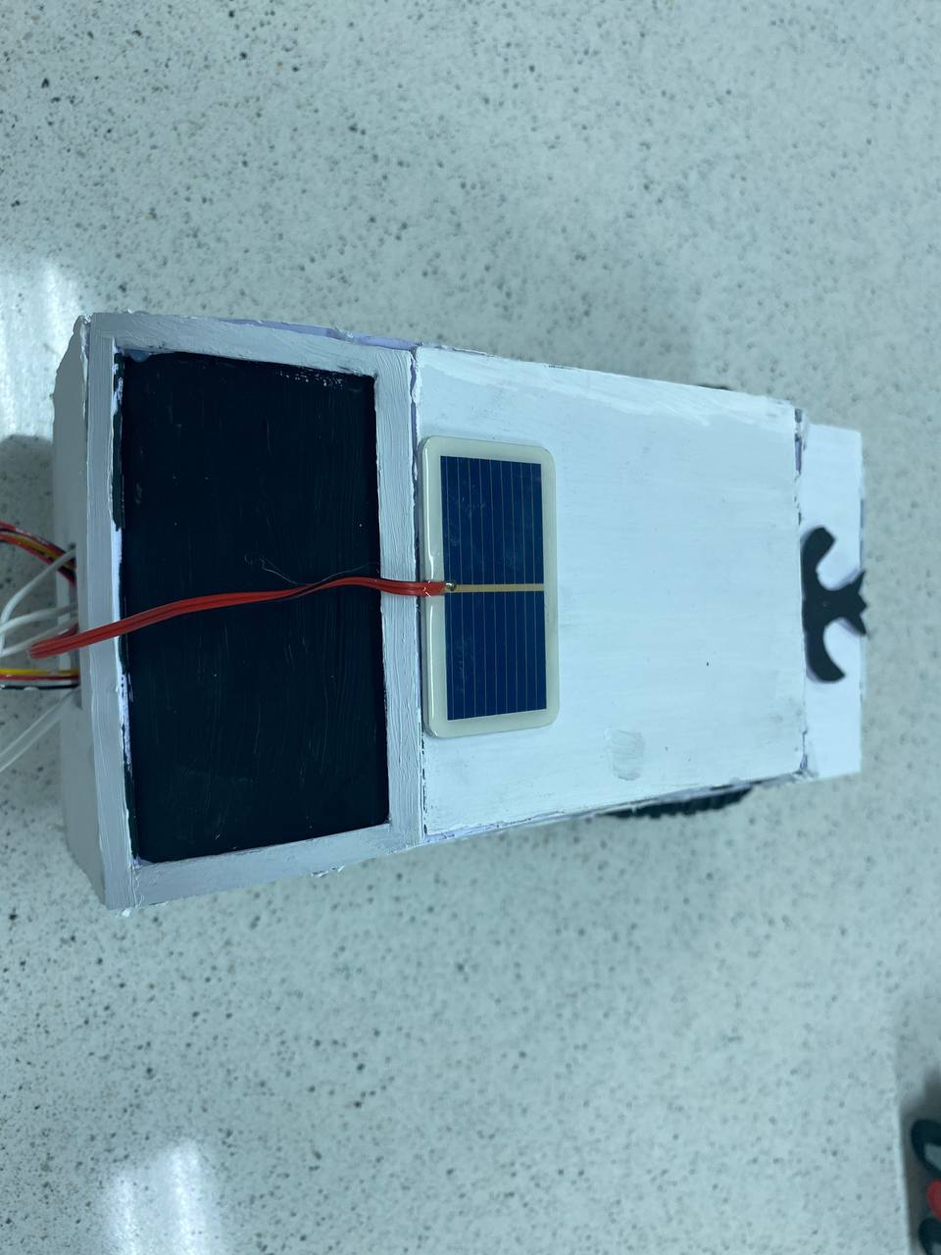

The car gets the power from the solar energy, so it limits the excessive use of another energy sources. Due to this the amount of energy and finances that are spent on charging the car reduces.

### Electric motor

The car's engine runs entirely on electricity. That’s why it does not produce any waste to the environment in comparison to other motors.

### Distance sensor

With the help of distance sensor, the objects that are getting closer to the car can be detected and the driver will be warned. This can be useful, especially when car is parking, or the driver is distracted, and another car is coming towards him. By this the road accidents can be prevented.

### Open flame sensor

The fire inside or outside of the car can be detected with the help of open flame sensor that immediately warns the driver to start the evacuation. By this the driver and passengers can save their lives.

### Gas leak sensor

Car equipped with gas leak sensor detects the leak of gas and warns the driver. Thanks to this it is possible to prevent gas poisoning.

### Temperature sensor

The temperature sensor of the automobile measures the air temperature inside and outside the car.

### Program code

// The program code is available in the GitHub <https://github.com/hecker0makhambet/jorga>

const int trigPin = 12;

const int echoPin = 13;

const int buttonPin = 2;

const int gas_pin = 2;

#define flame_pin A1

#define gas_pin_a A2

#define passivePin 8

#define buzz_pin 7

long duration, cm;

void setup(){

Serial.begin(9600);

pinMode(trigPin, OUTPUT);

pinMode(echoPin, INPUT);

pinMode(buttonPin, INPUT);

pinMode(buzz_pin, OUTPUT);

pinMode(flame_pin, INPUT);

pinMode(passivePin, OUTPUT);

pinMode(gas_pin, INPUT);

pinMode(gas_pin_a, INPUT);

}

void loop(){

digitalWrite(trigPin, LOW);

delayMicroseconds(5);

digitalWrite(trigPin, HIGH);

delayMicroseconds(10);

digitalWrite(trigPin, LOW);

duration = pulseIn(echoPin, HIGH);

cm = (duration / 2) / 29.1;

Serial.print("Расстояние до объекта: ");

Serial.print(cm);

Serial.println(" см.");

if(cm < 30){

digitalWrite(buzz_pin, HIGH);

}else{

digitalWrite(buzz_pin, LOW);

}

int value = analogRead(flame_pin);

int range = map(value, 0, 1024, 0, 3);

Serial.print(value);

switch (range) {

case 0:

Serial.println(" - ** Close Fire **");

tone(passivePin, 1000);

break;

case 1:

Serial.println(" - ** Distant Fire **");

tone(passivePin, 500);

break;

case 2:

Serial.println(" - No Fire");

noTone(passivePin);

break;

}

delay(1);

delay(250);

int gas_value = analogRead(gas_pin_a);

int digital = digitalRead(gas_pin);

Serial.println(String(gas_value) + " - " + String(digital));

if(gas_value > 100){

tone(passivePin, 250, 200);

}

}

**The work principle of the machine is shown in the figure below:**

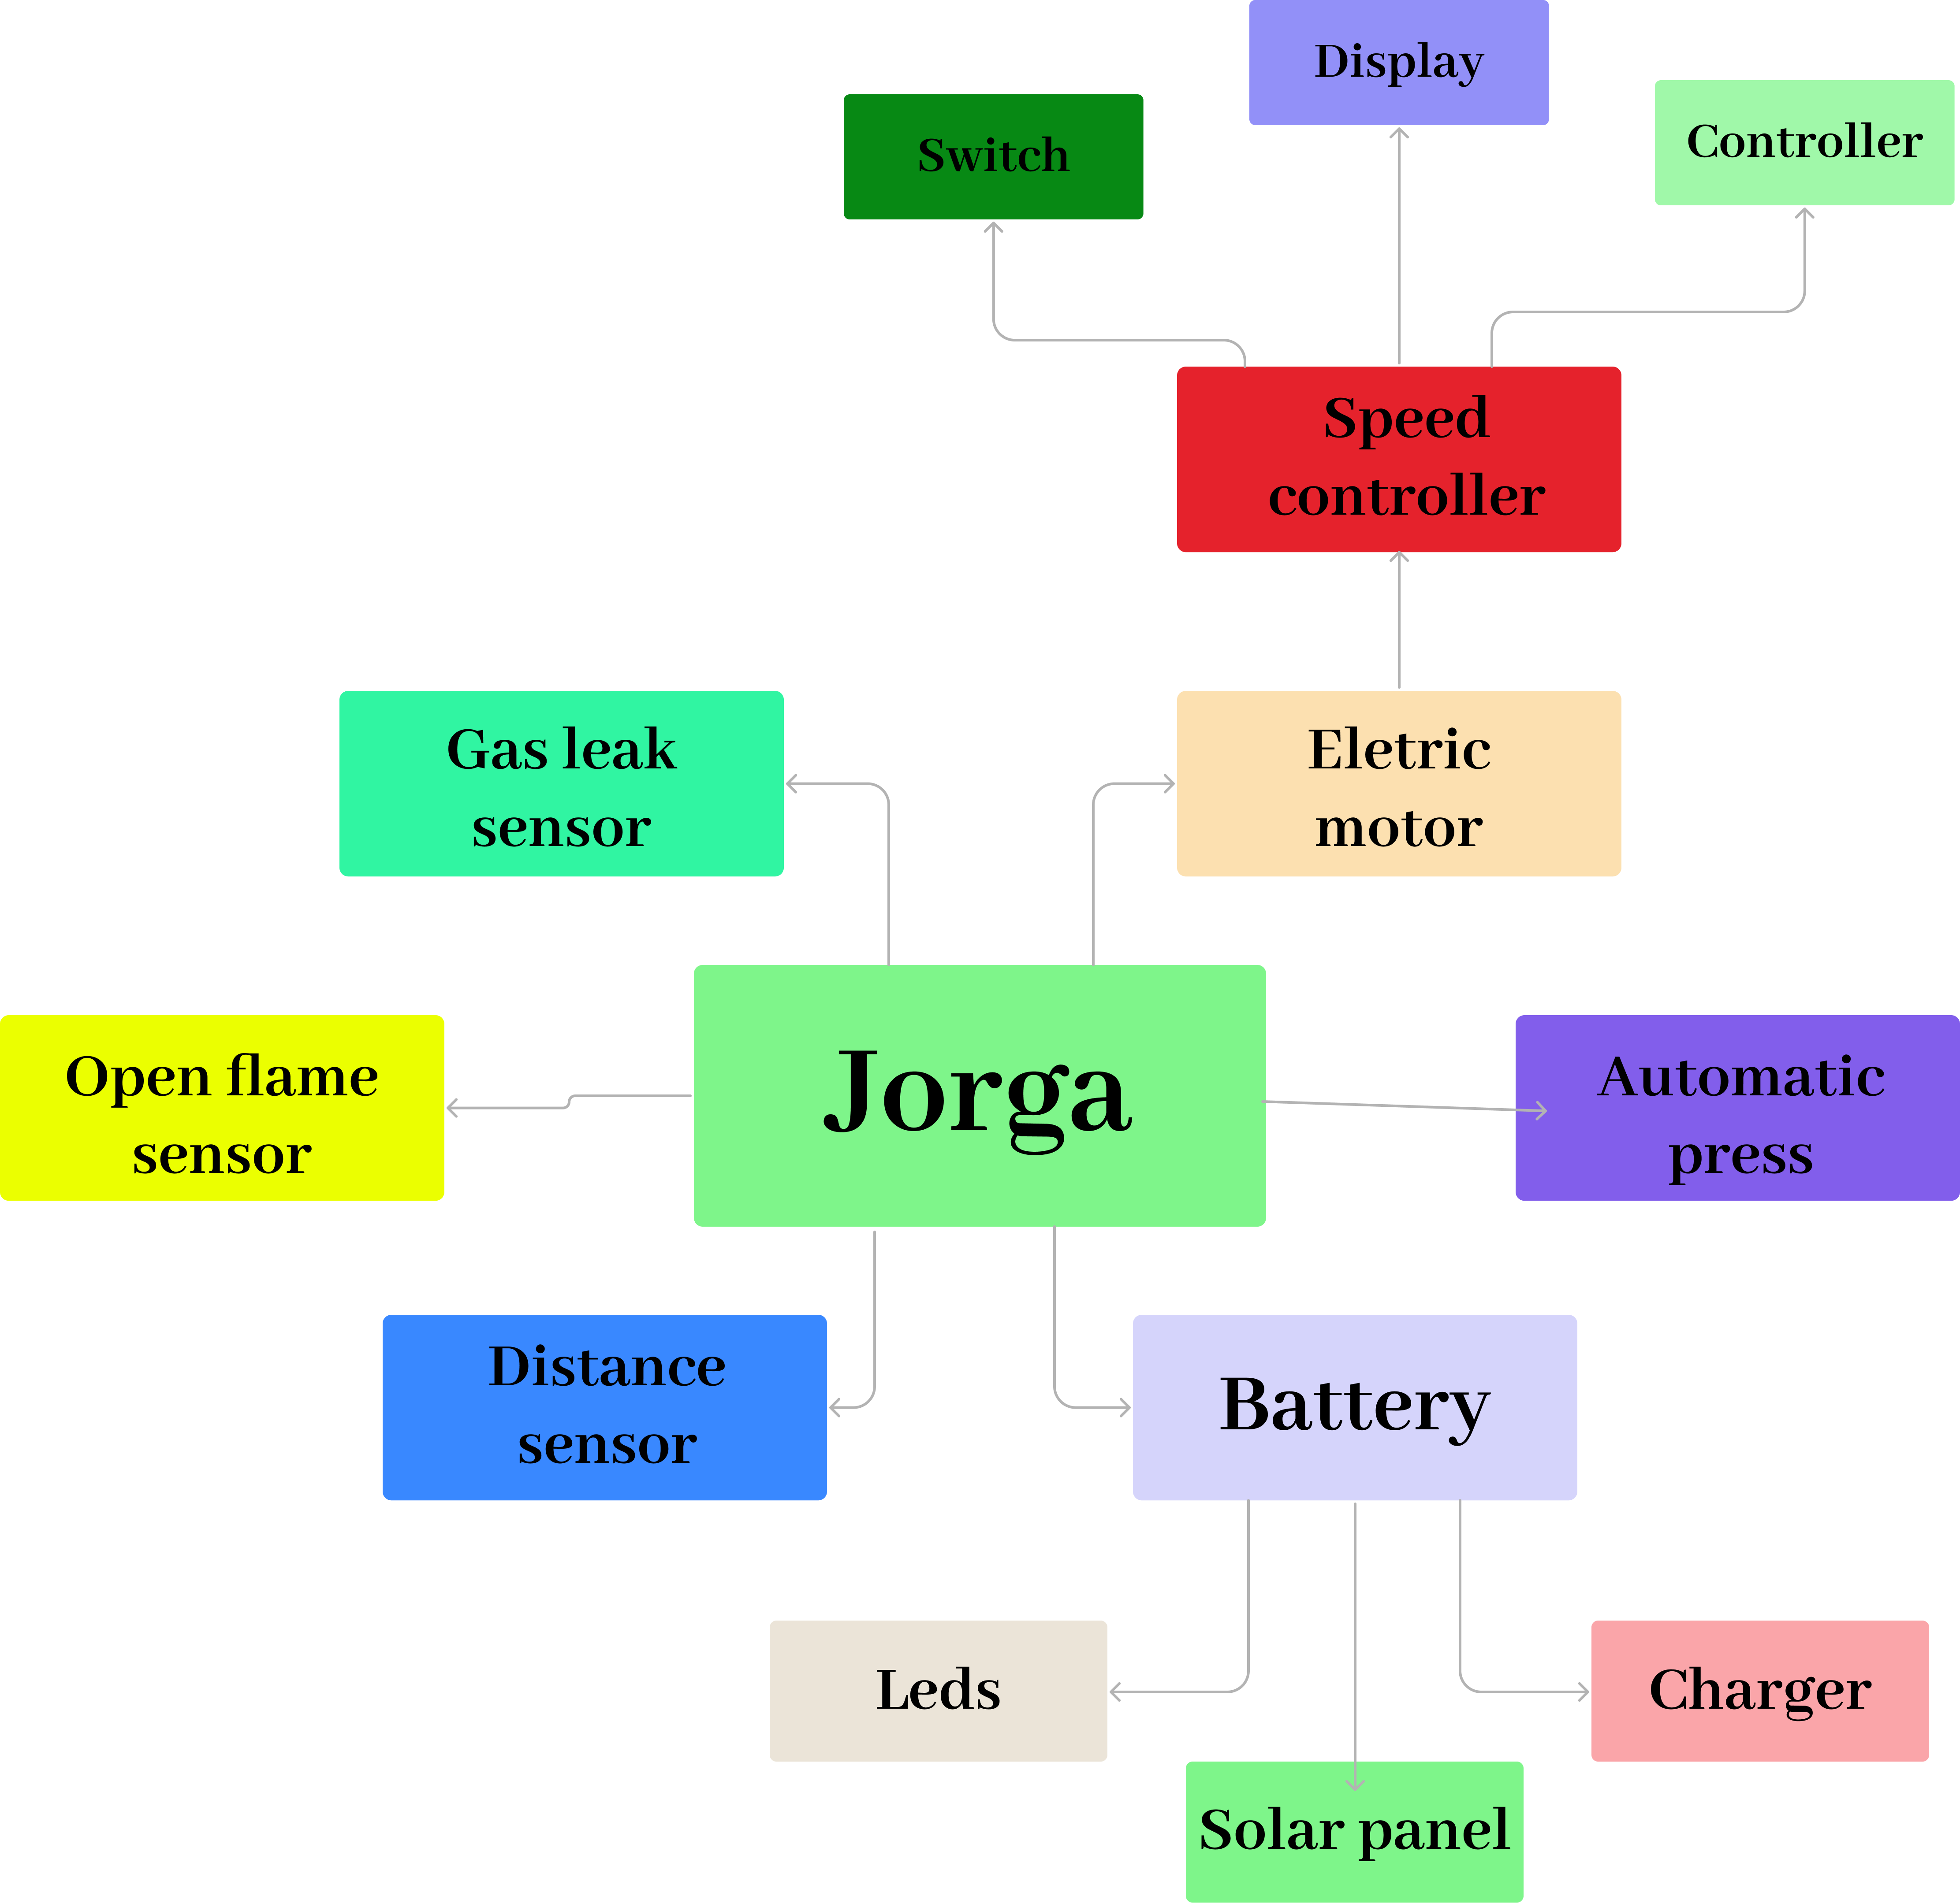

# Conclusion

In conclusion, as a result of this project, we considered two pressing problems in our country. The first is the uncompetitiveness of the country's auto industry. The second is air pollution, that is, an increase in the volume of harmful gases released into the environment. In the course of the project, we studied these two issues, analyzed the identified information and proposed a solution to the problem. Our project, which is not inferior to competing products on the market, offers a completely waste-free, environmentally friendly, solar-powered domestic car instead of cars that release 200 kg of gas per year. Thanks to this project, the automotive industry of Kazakhstan will be able to reach a new level. In the future, we plan to start production of the first products and conduct the first sales.

# Used literature

* <https://ortcom.kz/ru/novosti/1683800964>
* <https://bizmedia.kz/2023/04/21/vybrosy-vyhlopnyh-gazov-avtomobilej-odin-iz-osnovnyh-istochnikov-zagryazneniya-vozduha-v-almaty/>
* <https://www.inform.kz/ru/kazahstan-zanimaet-20-mesto-v-mire-po-vybrosam-uglekislogo-gaza_a3945128>
* <https://www.the-village-kz.com/village/city/situation/16681-naskolko-smertelen-gryaznyy-vozduh-v-almaty>
* <https://akab.kz/avtoprom-rk-itogi-semi-mesyaczev-2023-goda/>
* <https://www.caravan.kz/news/my-dazhe-boltiki-sami-ne-proizvodim-pochemu-kazakhstancy-gotovy-pokupat-problemnye-avto-iz-rossii-vmesto-otechestvennykh-788979/>